Sonar Scan Integration to Jenkins

Contents

1 Revision History 2

2 Objective / Purpose of the Document 2

3 Steps for Sonar scan job creation 3

4 Process of getting access to dashboards 4

5 References 6

# Revision History

|  |  |  |  |
| --- | --- | --- | --- |
| **Date** | **High Level Description of Change (Indicate Section Updated)** | **Author** | **Approver** |
| 8/29/2017 | Initial Integration details | Naidu VA |  |

# Objective / Purpose of the Document

SonarQube provides the capability to not only show health of an application but also to highlight issues newly introduced. With a Quality Gate in place, you can fix the leak and therefore improve code quality systematically.

The intention of this document is to provide the basic information on Integrating the Sonar scan to Jenkins Jobs.

<http://sonar.optum.com/>

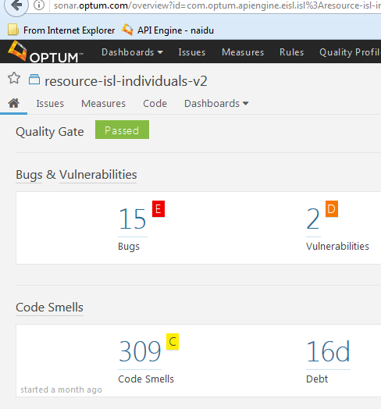

# Steps for Creating Sonar scan job

Create a maven project in your Jenkins instance.

Execute this below shell script in a Execute Shell plugin in build phase of maven project.

|  |
| --- |
| export JAVA_HOME=/tools/java/jdk1.8.0_121  export M3_HOME=/tools/maven/apache-maven-3.3.3  export PATH=$JAVA_HOME/bin:$M3_HOME/bin:$PATH  mvn org.sonarsource.scanner.maven:sonar-maven-plugin:3.1.1:sonar -e \  -Dsonar.host.url=http://sonar.optum.com -Dsonar.login=092c919905283a6d35ff1abe2128fc52e48a6156 \  -Dsonar.links.scm=${GIT_URL} -Dsonar.links.ci="${BUILD_URL}" \  -Dsonar.scm.provider=svn \  -Dsonar.svn.username=${MAVEN_USER} \  -Dsonar.svn.password.secured=${MAVEN_PASS} \ |

Once you ran this maven project. Sonar scan report will get generated and uploaded to Sonar.optum.com with the same project name in your SCM pom.xml.

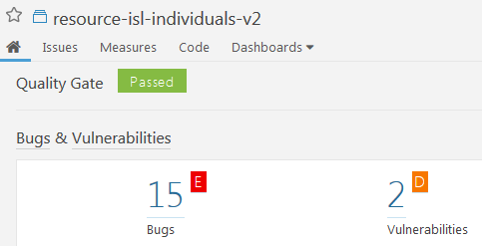

Now access the sonar.optum.com. and search for your project. You can see the report statistics. But it will not be in an organized manner ( customized dashboard: we will call them as views ).

To make our own report organized we have to request sonar team with all projects that we are going to execute the sonar scan.

**Creating views/ dashboards**

Once we executed the sonar scan jobs, we need our own dashboard created in sonar.optum.com with all our appropriate scan analysis reports. for this we need to provide the navigation flow for your project. Refer the below ne for OIL project which I have given.

Polaris🡪UHC-OIL🡪Resource –isl-findIndividuals

🡪RB1.x

🡪RB2.X

**Sonar Admin team to contact:**

**Devarasetty, Hareesh** [**hareesh_devarasetty@optum.com**](mailto:hareesh_devarasetty@optum.com)

**Steele, Paul C <paul.steele@optum.com>**

# Process of getting access to dashboards

After our scan results are uploaded to Sonar-optum.com, we need to get access for thse dashboards.

Permissions will be in 3 types which are explained here.

|  |
| --- |
| Permissions are not set at the individual level.   We use MS-Groups created using SECURE which is the corporate standard for building and maintaining secure groups.   1. Viewing source code in SonarQube requires permissions to be set.   Permissions in SonarQube are managed using MS Groups created through SECURE.   If you don’t have existing MS Groups that can be leveraged you will need to create new MS Groups in SECURE.      1. There are three types of permissions in SonarQube.  For each type you will need to send me the name of the MS Group.    * Type 1 - Individuals in this MS Group are allowed to **view the source code**.   This MS-Group contains all the names of the developers accessing SonarQube who need to see source code.    * (**optional**) Type 2 - Individuals in this MS Group are allowed to **mark issuers as false positives, assign them to developers, etc.**    This MS-Group contains the names of Lead Developers and/or admins who will be managing issues in SonarQube.    * (**optional**) Type 3 - Individuals in this MS Group are allowed to administer the project - **change a quality gate, delete a project**.   This MS-Group is usually the same as the one used to manage issues but doesn’t have to be.      1. **Once you have your MS-Groups, send them to me along with the link to the SonarQube project(s), that need their permissions set.** |

In short, create 2 windows groups through secure. One is for Admin access and second one is for issue management.

And create a service now request with the created 2 windows secure groups. And make sure to provide the detailed description. Refer my Service now ticket.

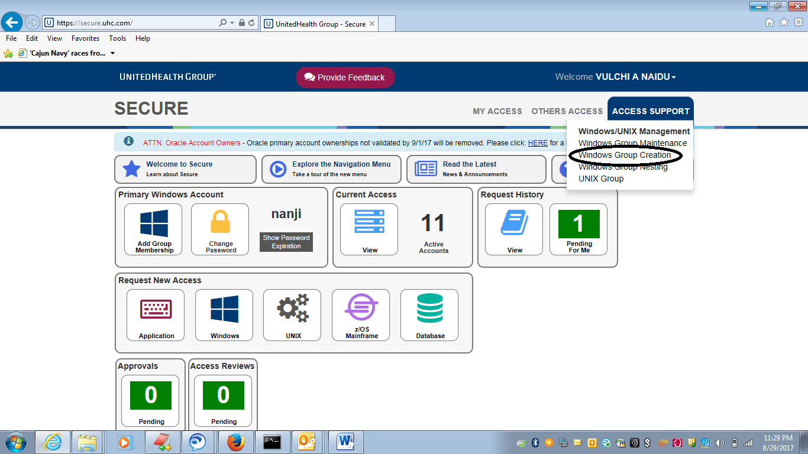

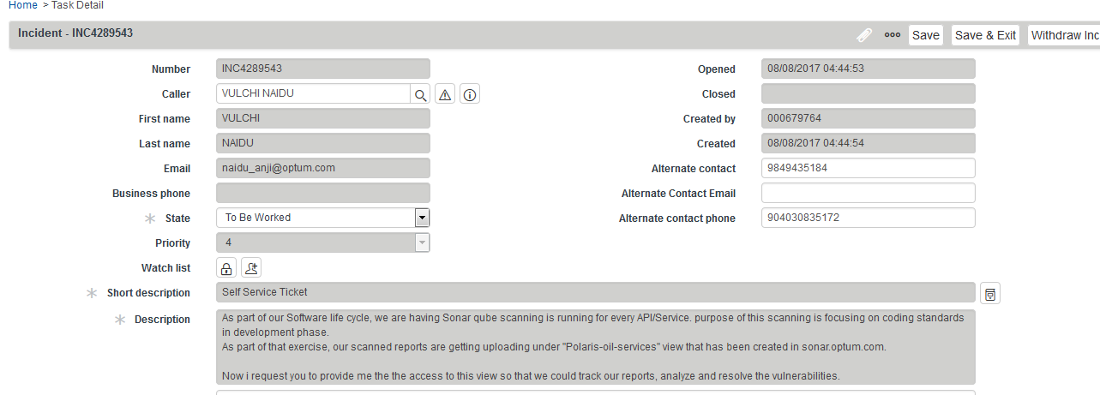

After raised the service now ticket, contact **Steele, Paul C** [**paul.steele@optum.com**](mailto:paul.steele@optum.com)**.** He will help for further formalities. If you are part of Admin group, you can see all issues and can perform all opertations like,

Moniter the code

Issue resolution

Making false positive. Etc…

After all steps has completed, you will be able to see your dashboard which will looks like this,

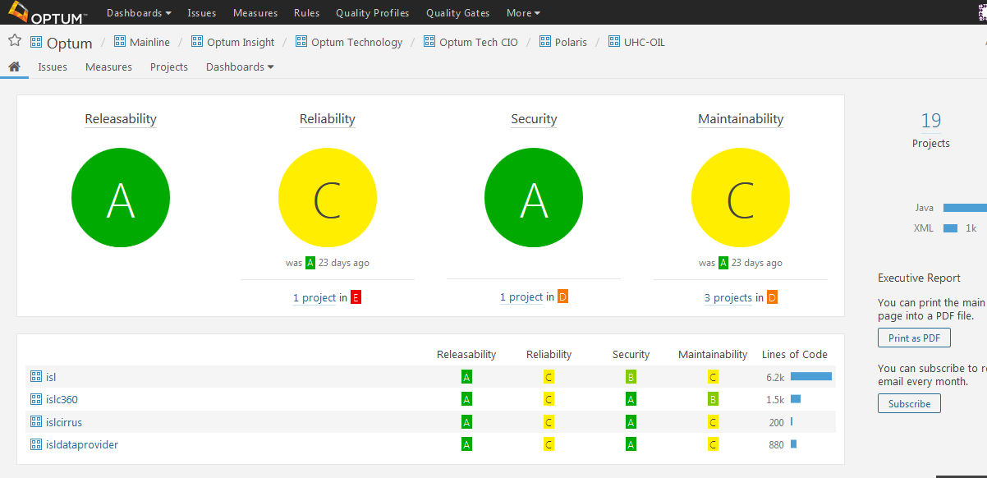

# References

<https://www.sonarqube.org/>

http://sonar.optum.com/